Chemistry 20

Lesson 20 – Dissociation

# Testing electrical conductivity of solutions

In chemistry we deal with the **observed** properties of compounds, chemical reactions, etc. and we find **theories** to explain the observed properties. An **operational definition** is a way to talk about a compound or a chemical reaction in terms of empirical, observed properties. A **conceptual definition** is a theory (concept) that attempts to explain the observed properties. The following are operational definitions for electrolytes and non-electrolytes.

An **electrolyte** is a solution that conducts electricity.

A **non-electrolyte** is a solution that does not conduct electricity.

Using a conductivity tester, determine whether the following solutions are electrolytes or non-electrolytes.

* Thoroughly rinse the wires of the conductivity tester in distilled water between tests.
* Place the leads into the solution and note whether the light turns on or not.
* Also note how strongly the solution conducts – you may want to do the tests in a darkened room in order to see subtle effects.
* Once you have tested all of the solutions, discuss the results with your kind and benevolent teacher.

|  |  |  |  |  |  |
| --- | --- | --- | --- | --- | --- |
| **Substance** | **Type of substance** | **Conducts electricity?** | **Strong Electrolyte** | **Weak Electrolyte** | **Non − Electrolyte** |
| H2O (l) (distilled) |  |  |  |  |  |
| H2O (l) (tap) |  |  |  |  |  |
| NaCl (aq) |  |  |  |  |  |
| H2SO4 (aq) |  |  |  |  |  |
| KNO3 (aq) |  |  |  |  |  |
| CH3COOH (aq) |  |  |  |  |  |
| KOH (aq) |  |  |  |  |  |
| CH3OH (aq) |  |  |  |  |  |
| HCl (aq) |  |  |  |  |  |
| C12H22O11 (aq) |  |  |  |  |  |
| NaOH (aq) |  |  |  |  |  |

### Conclusions:

What kinds of substances are electrolytes?

What kinds of substances are non-electrolytes?

# Electrolytes and dissociation

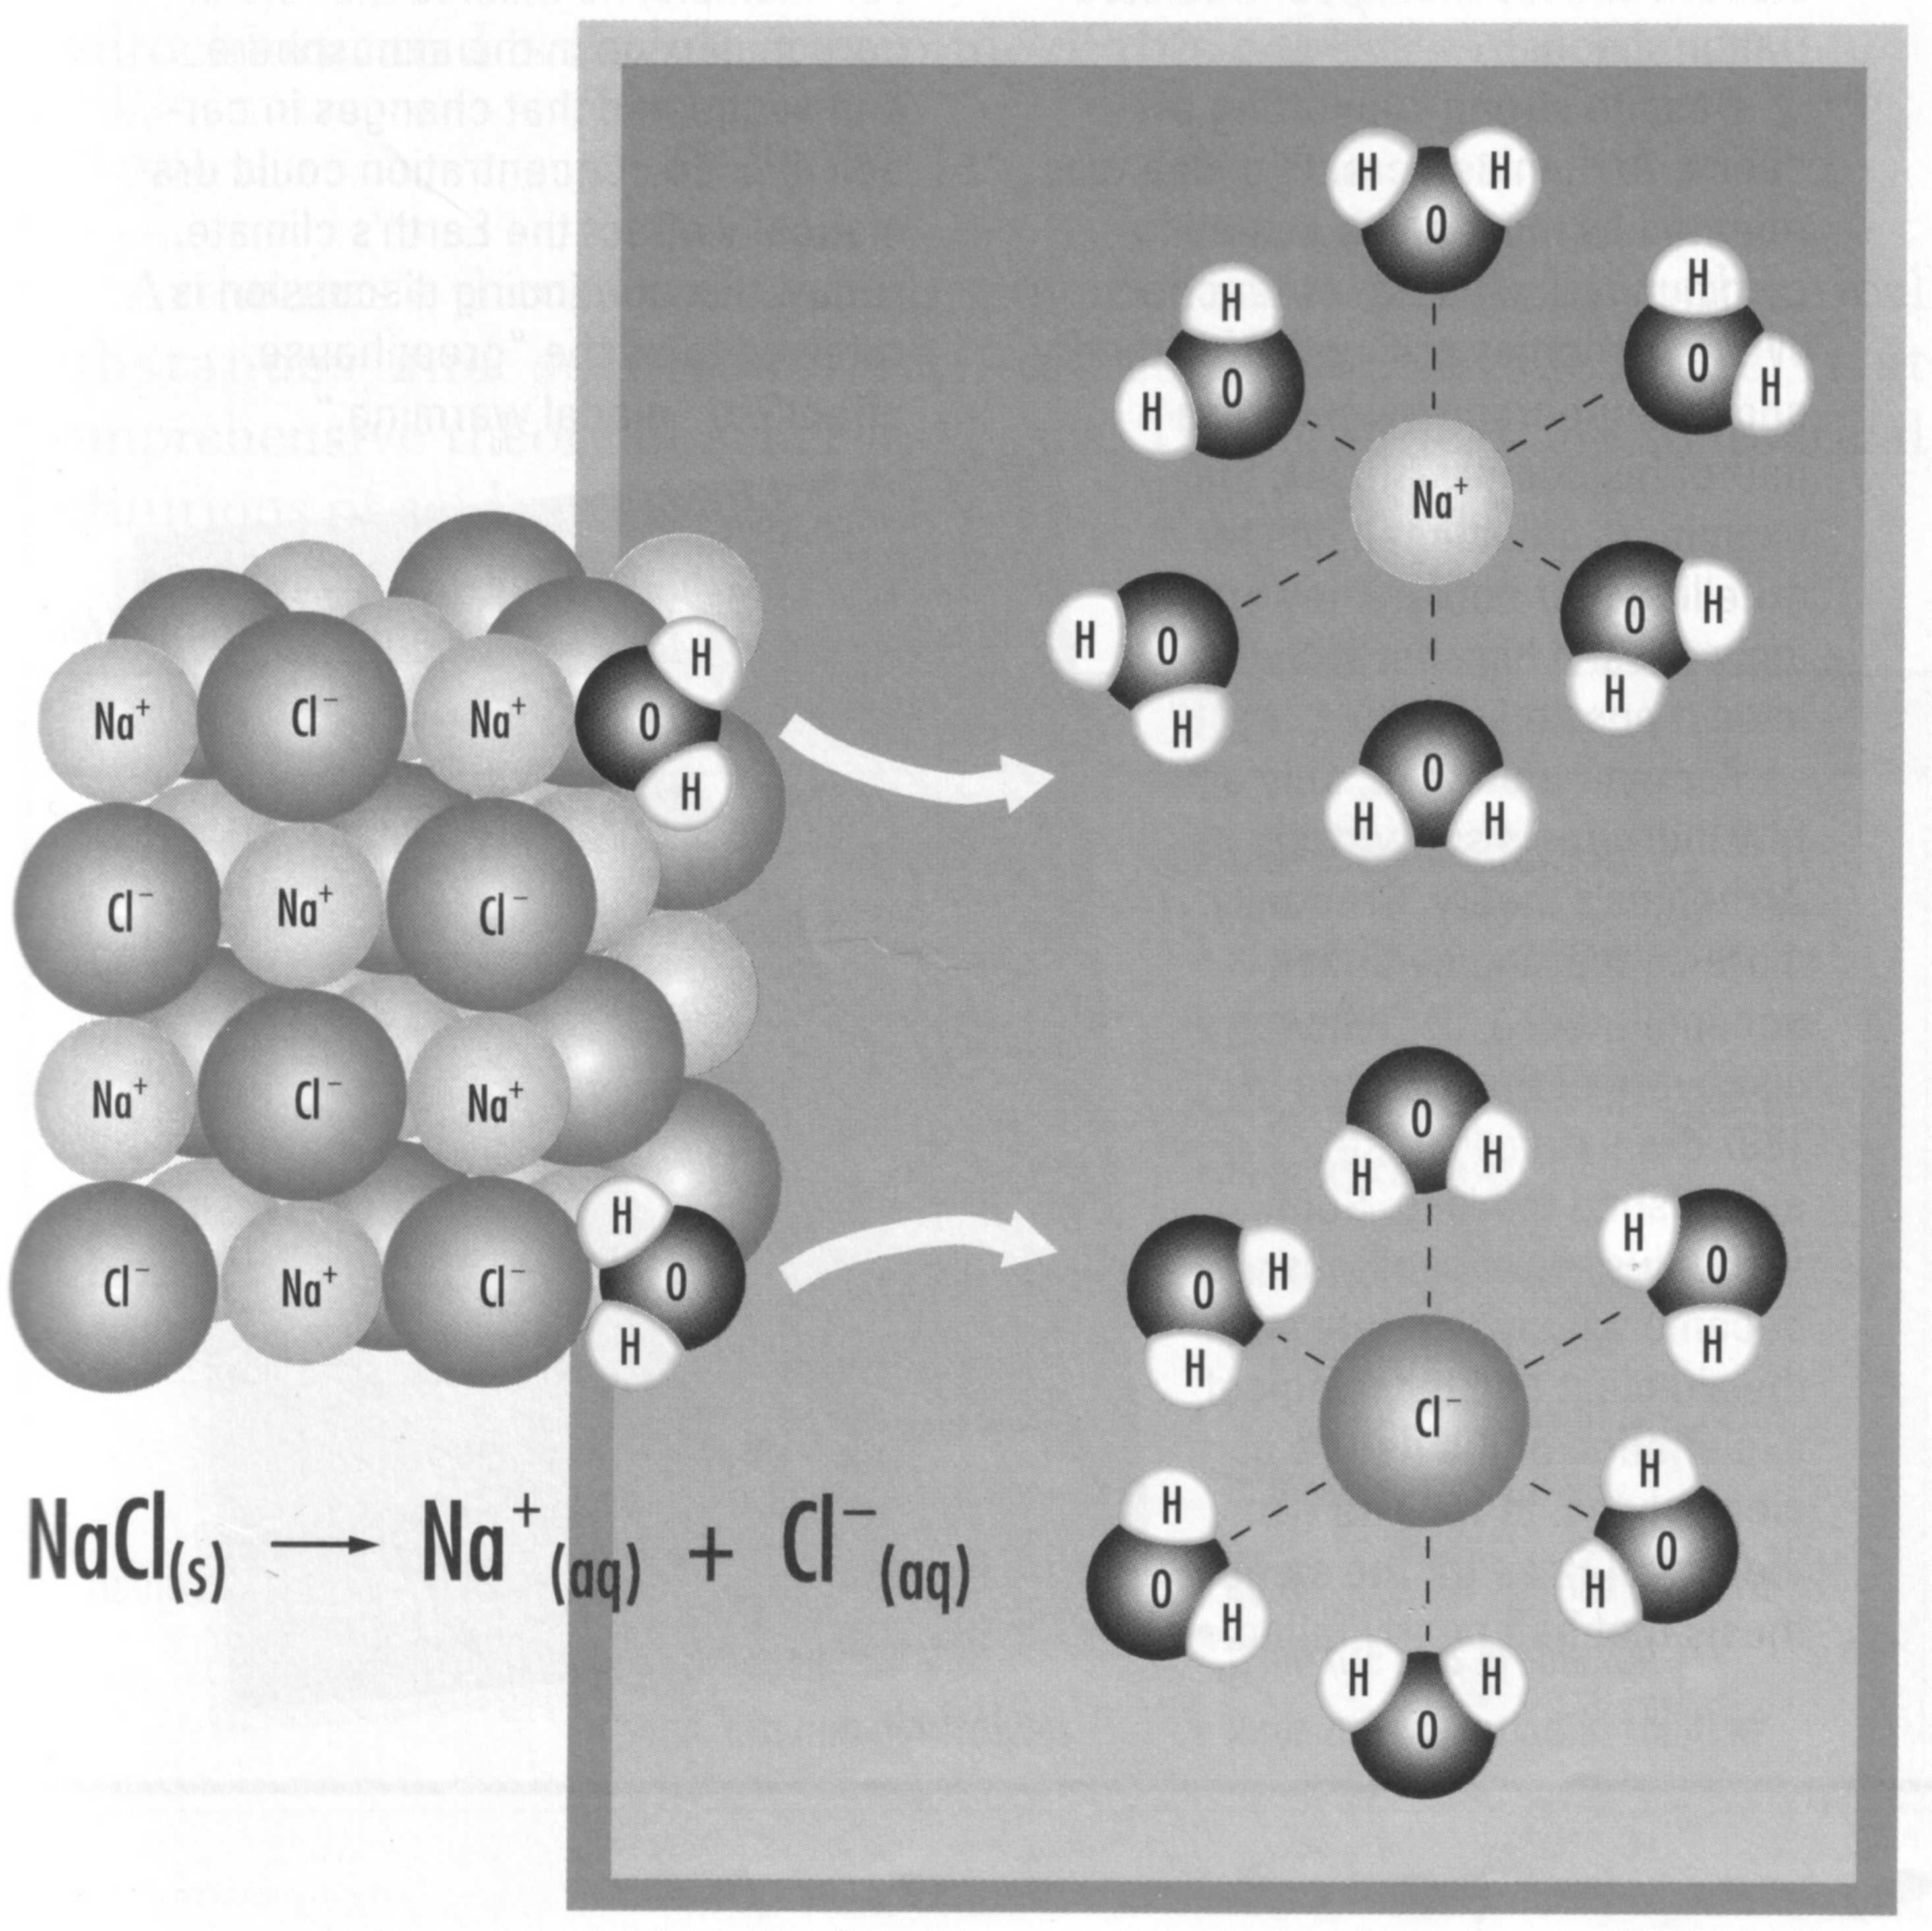The flow of electricity requires the presence of charges, either ions or electrons, that are free to move or flow. Since electrolytes conduct electricity, electrolytic solutions must contain ions in solution. Further, since soluble ionic compounds and strong acids are strongly electrolytic we can conclude that they produce ions in solution. For ionic compounds, when the solid ionic crystal dissolves in water the ions are separated or dissociated. In other words, the aqueous ionic compound exists as separate cations and anions. The breaking apart into ions is a physical process called **dissociation**. For soluble ionic compounds dissociation occurs due to the polar nature of water. Using the dissolving of sodium chloride as an example, the negative ends of the water molecules surround the cations, while the positive ends of water molecules surround the anions.

Strictly speaking, only ionic compounds dissociate. Molecular compounds that form ions in water (i.e. acids) are said to **ionize**. Unlike dissociation, which is a physical process, **ionization** involves a chemical reaction with water to form the ions which makes it a chemical process. You will learn more about ionization in the acid/base unit of this course. For now we will limit ourselves to discussing the dissociation of ionic compounds.

When writing dissociation equations for soluble ionic compounds, one should follow these rules:

1. The dissociation equation must be balanced.

2. The equation must show the correct ionic charges.

3. The equation must show physical states.

Writing proper dissociation equations is illustrated in the following examples:

1. Write the dissociation equation for sodium chloride dissolving in water.

Note that the original ionic solute is written as a solid and the ions have aqueous subscripts.

NaCl (s) → Na+ (aq) + Cl− (aq)

2. Write the dissociation equation for rubidium sulfide.

Rb2S (s) → 2 Rb+ (aq) + S2− (aq)

Note that for every rubidium sulfide formula unit, two rubidium ions are dissociated into solution.

3. Dissociate ammonium sulphate.

(NH4)2SO4 (s) → 2 NH4+ (aq) + SO42− (aq)

Note that complex ions remain as complex ions and are not broken down any further.

4. Lithium chloride tetrahydrate is added to water.

LiCl · 4H2O(s) → Li+ (aq) + Cl− (aq) + 4 H2O(l)

Note that the water in the ionic crystal is released and becomes part of the solvent. It is H2O(l) and not H2O(aq).

# sucrose dissociationNon-electrolytes

Non-electrolytes, on the other hand, do not conduct electricity. This indicates that when molecular compounds dissolve in water, they remain as neutral individual molecules. Thus, solid sucrose dissolves to become aqueous sucrose.

C12H22O11 (s) → C12H22O11 (aq)

Another example is when ethanol is added to water

C2H5OH (l) → C2H5OH (aq)

# Ionic concentration

As we saw earlier in this lesson, ionic compounds do not exist as, for example, Rb2S (aq)  when in solution. Rather, rubidium sulfide exists as Rb+ ions and S2− ions in solution:

Rb2S (s) → 2 Rb+ (aq) + S2− (aq)

Rb2S

Rb2S

Rb2S

Rb2S

Rb2S

Rb2S

Rb2S

Rb2S

Rb2S

Rb2S

Note that the coefficient in front of the rubidium ion is a 2. This indicates that the concentration of the rubidium ions is 2 times the concentration of rubidium sulfide solution. If, for example, the rubidium sulfide solution had a concentration of 10 per litre,

Rb+

S2−

Rb+

Rb+

Rb+

Rb+

Rb+

Rb+

Rb+

Rb+

Rb+

Rb+

Rb+

Rb+

Rb+

Rb+

Rb+

Rb+

Rb+

Rb+

Rb+

S2−

S2−

S2−

S2−

S2−

S2−

S2−

S2−

S2−

S2−

the rubidium ion concentration would be 20 per litre and the sulfide ion concentration would be 10 per litre.

In a 0.23 mol/L aluminum sulfate solution, what is the molar concentration of each ion?

**Step 1:** Write a balanced dissociation equation.

Al2(SO4)3 (s) → 2 Al3+ (aq) + 3 SO42− (aq)

Each mole of aluminum sulfate yields two moles of aluminum ions and three moles of sulfate ions.

**Step 2:** Use mole ratios to determine the ion concentrations.

 = **0.46 mol/L**

 = **0.69 mol/L**

A solution contains 9.61 g of ammonium carbonate dissolved in water to form 400 mL of solution. What is the concentration of each ion in solution?



We first calculate the concentration of (NH4)2CO3 (aq):

(NH4)2CO3 (s) → 2 NH4+ (aq) + CO32− (aq)

 = **0.500 mol/L**

 = **0.250 mol/L**

# Practice problems

1. If the concentration of a calcium chloride solution is 0.10 mol/L, what is the concentration of each ion?

2. In an ammonium chromate solution where the ammonium ion concentration is 0.0466 mol/L, what is the concentration of the solute?

3. 35.1 g of aluminum dichromate is dissolved to form 200 mL of solution. What is the concentration of each ion in solution?

4. 15 mL of a 0.65 mol/L solution of strontium nitrate is diluted with 85 mL of water. What is the concentration of each ion in the new solution?

# Assignment

**Part A**

Instructions:

* Determine if the following substances will or will not dissolve in water.
* Chemically represent if they dissolve or dissociate.

a) sodium hydrogen sulfite

b) aluminum chloride hexahydrate

c) rubidium phosphate

d) calcium dihydrogen phosphate monohydrate

e) ammonium dichromate

f) silver chloride

g) sodium oxide

h) ethanol

i) ammonium perchlorate

j) barium hydroxide octahydrate

Which of the compounds above will form electrolytic solutions?

**Part B**

Instructions:

* Write the dissociation equation.
* Calculate what is asked for.

1. In a 0.23 mol/L aluminum sulfate solution, what is the concentration of each ion?

2. In a 0.090 mol/L sodium phosphate solution, what is the concentration of each ion?

3. A solution contains 9.61 g of ammonium carbonate dissolved in water to form 400 mL of solution. What is the concentration of the ions produced?

4. A fence post preservative solution is made by dissolving 800 g of zinc chloride in enough to make 4.50 L of solution. Calculate the concentration of each ion produced?

5. In an ammonium dichromate solution the ammonium ion concentration is 0.0466 mol/L. Calculate the concentration of the original solute.

6. What mass of calcium chloride is required to make 2.00 L of 0.120 mol/L chloride ion solution?

7. A 800 mL solution contains 50.0 g of NaBr. What is the concentration of each ion?

8. You are given 400 mL of a 1.25 mol/L solution of Al(NO3)3. What is the concentration of each ion?

9. 40.0 g of K2Cr2O7 is dissolved in water to make 700 mL of solution. What is the concentration of each ion?